Kavya Gundala

09-01-2024

**Creating a Repository on Azure DevOps:**

* Connect to Microsoft Azure portal with respected credentials. And in the search bar, search for Azure DevOps Organizations.

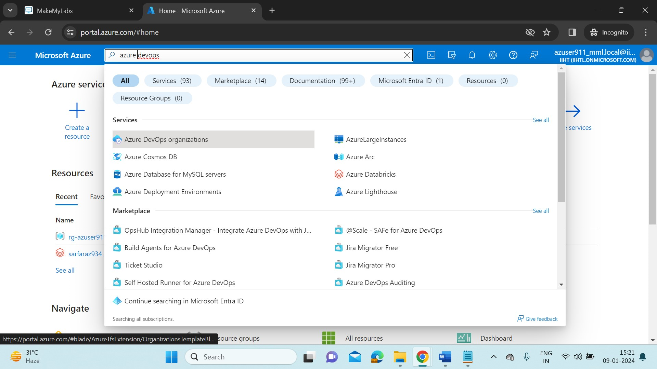

* After selecting the Azure DevOps Organizations, the below page will be displayed.

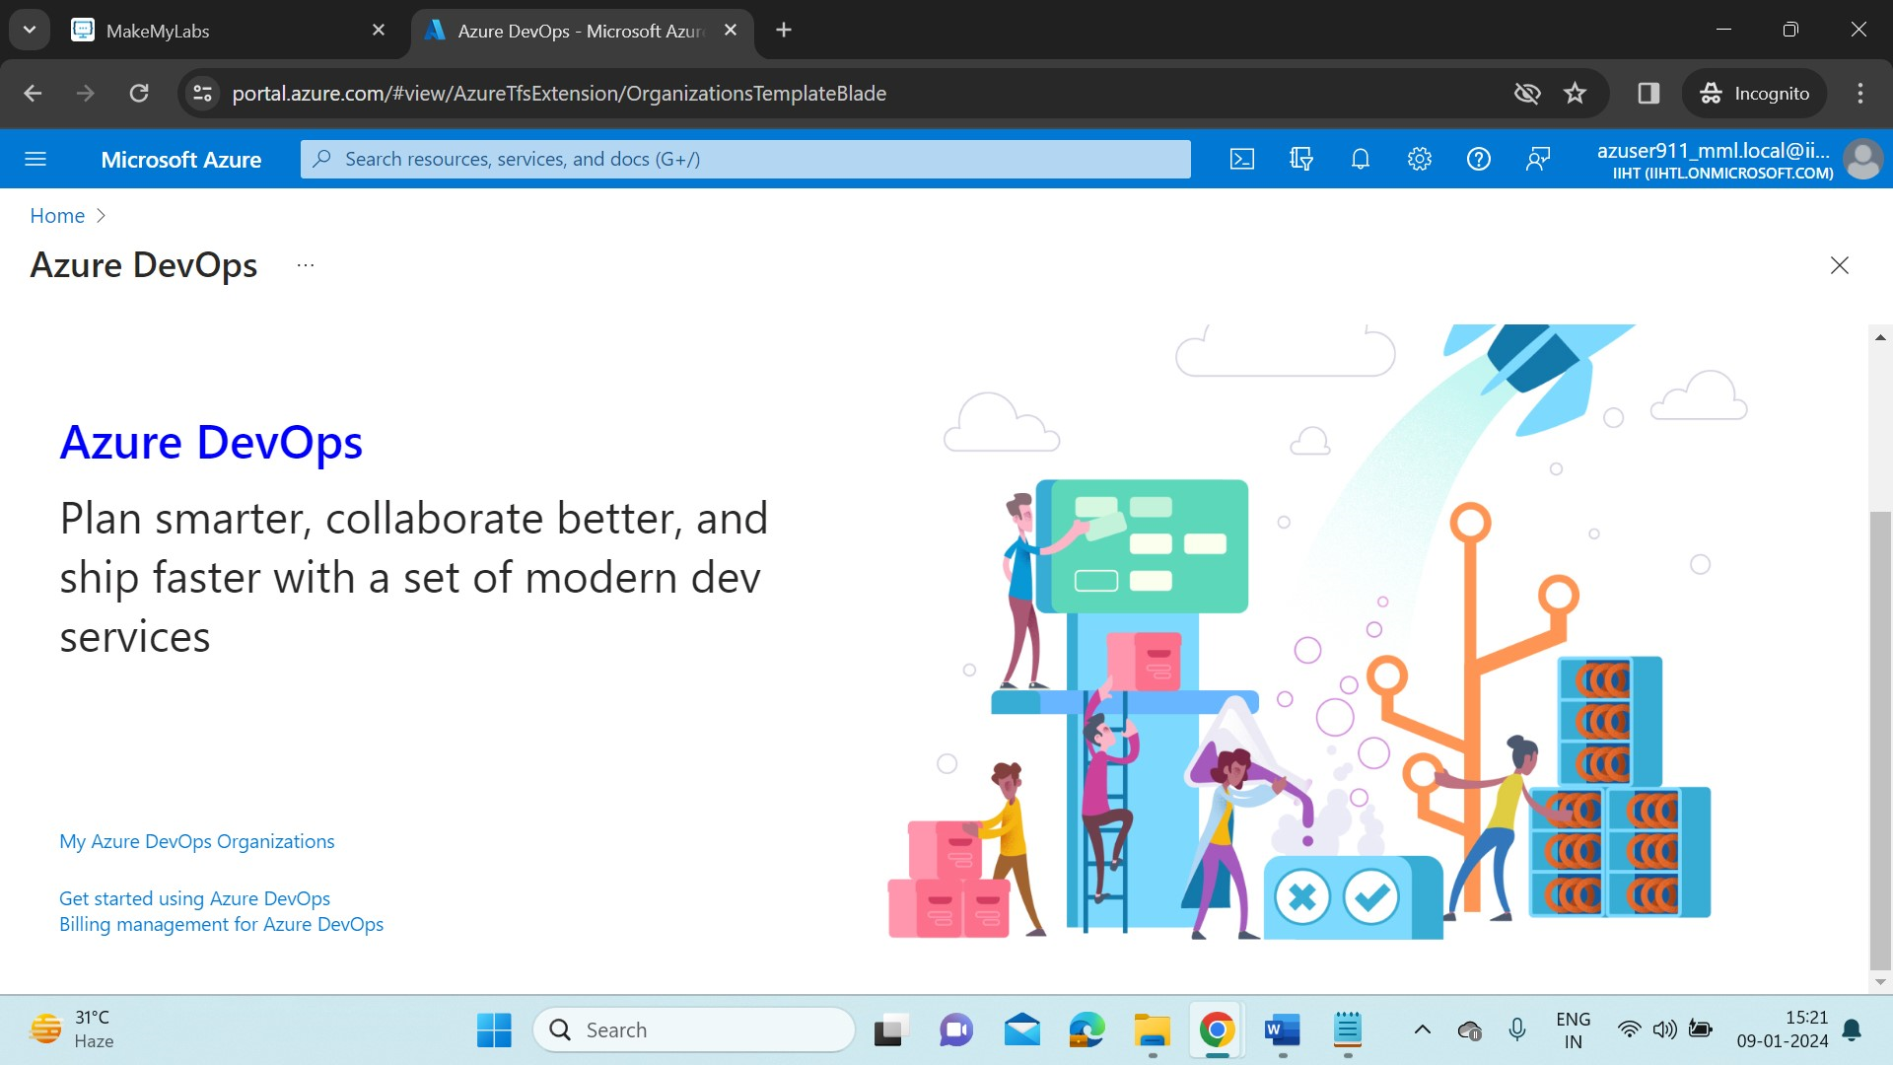

* Connect to My Azure DevOps Organizations. A new window will be opened in the browser asking for few more details.

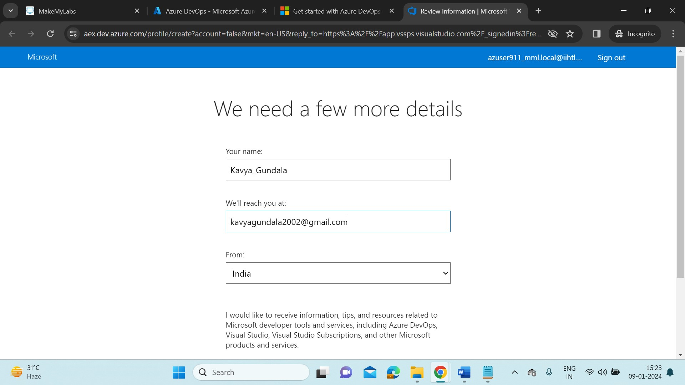

* Sign in with the details. It will create an Azure DevOps profile for us. The login page will redirect us to below page.

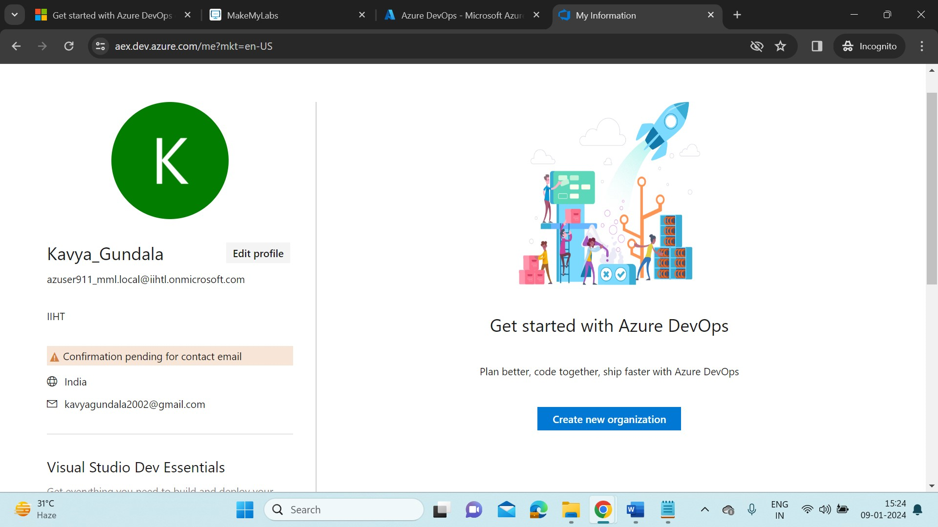

* Now let’s create a new organization. Provide details of your organization as “Hexaware66”.

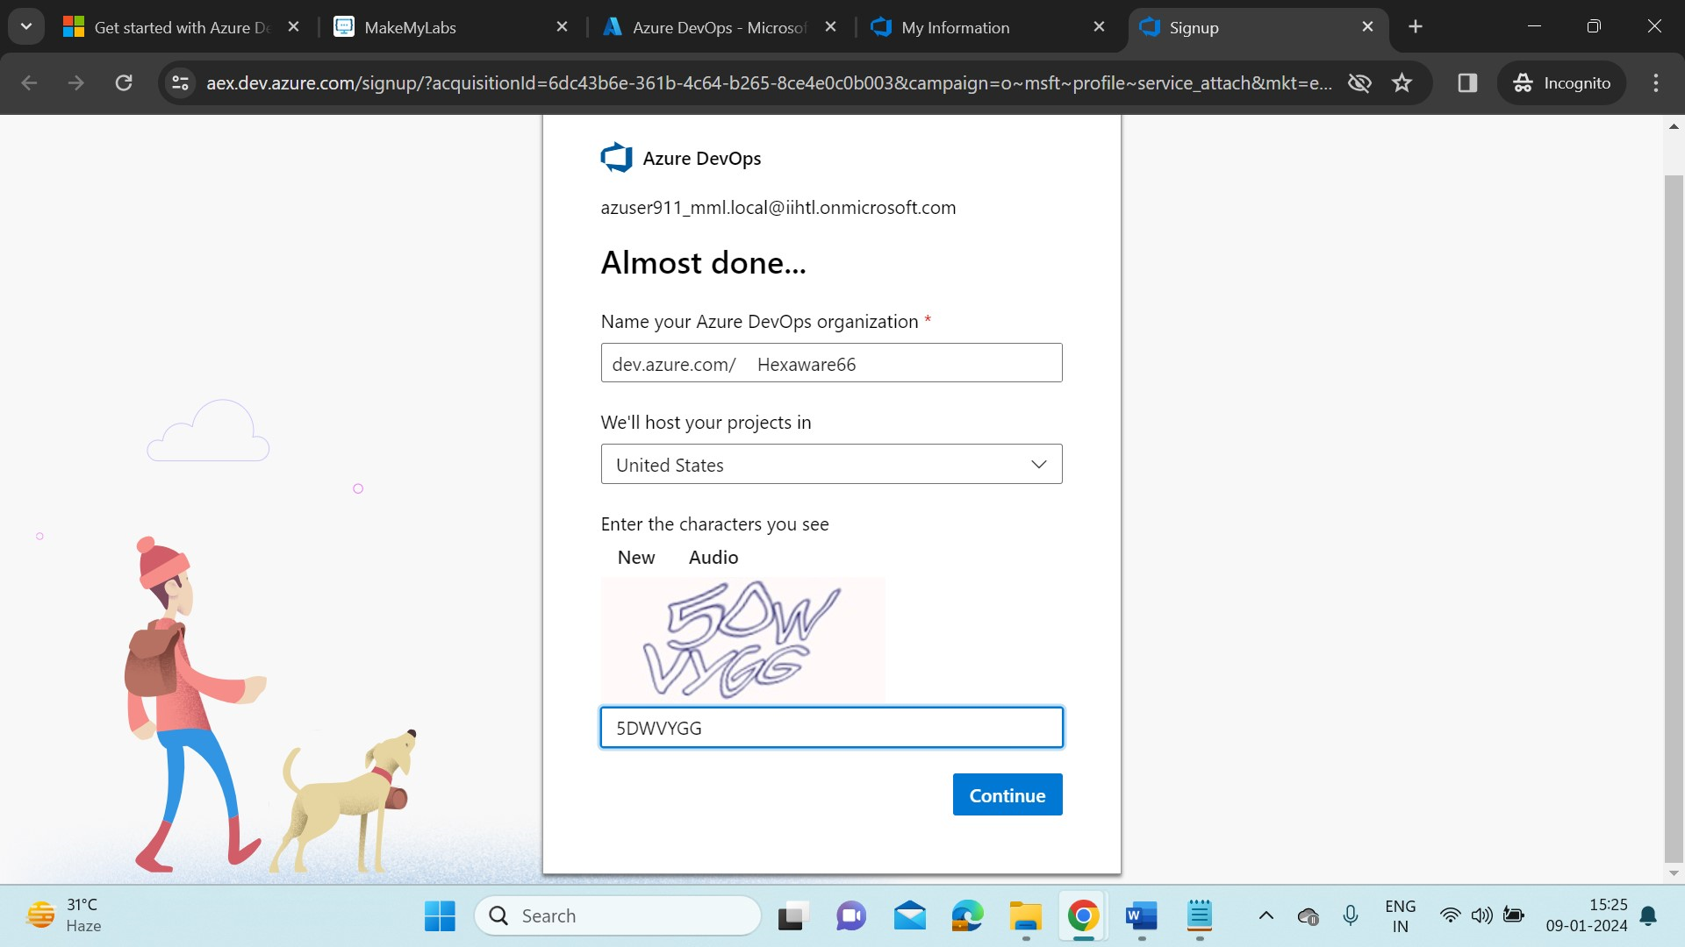

* Now we are in the Azure DevOps portal where we can continuously automate and integrate the processes between software development and IT teams.

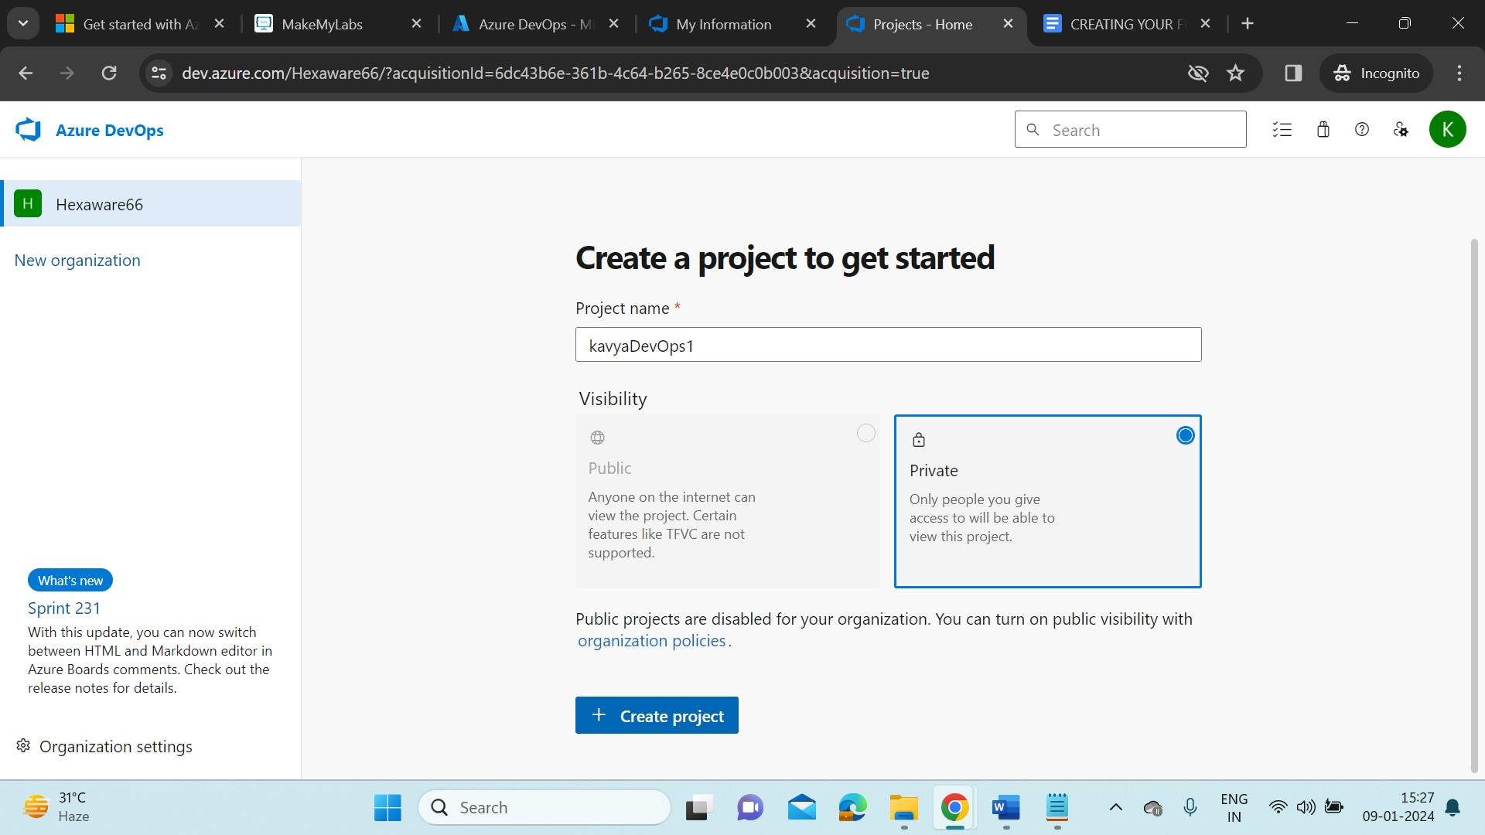

* Create a new Project “kavyaDevOps1”. Click on Create project. Now we can see the DevOps components provided by Microsoft Azure such as Repos, Boards, Pipelines, Test plans, Artifacts.
* Now to create a new repository, choose “Repos” from given components. Click on ‘+’ option to create a new repository.

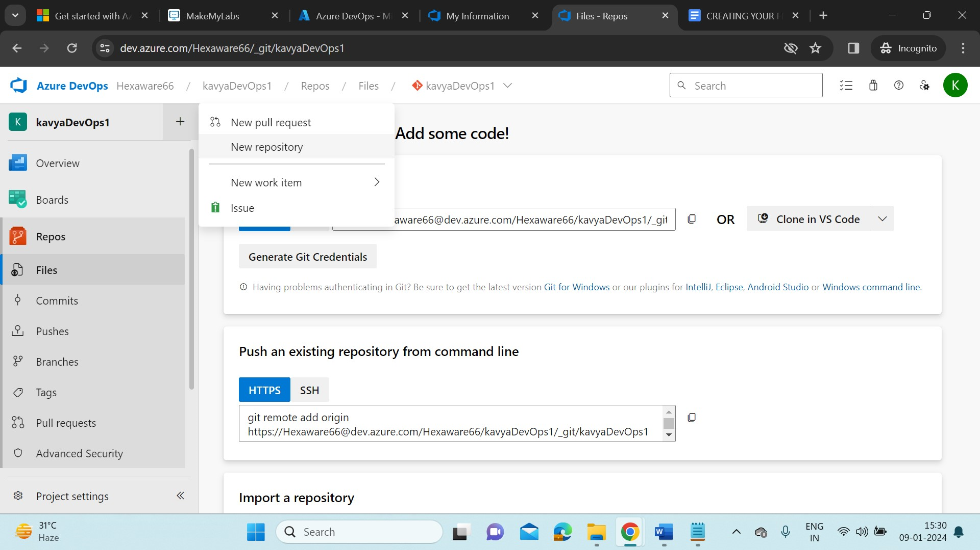

* Give the repository a name “Power bi version control”. Click on create.

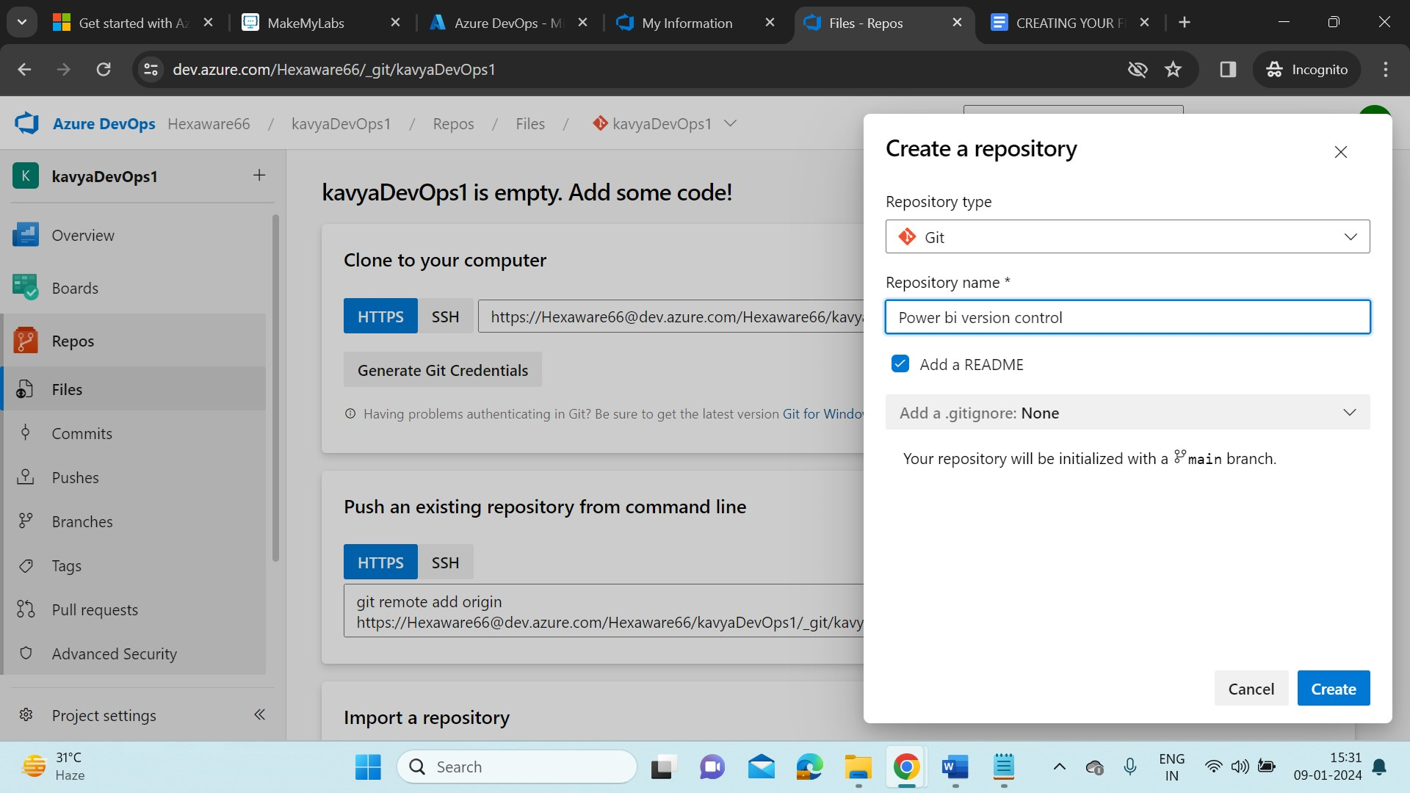

* The DevOps repository automatically creates a README.md file.

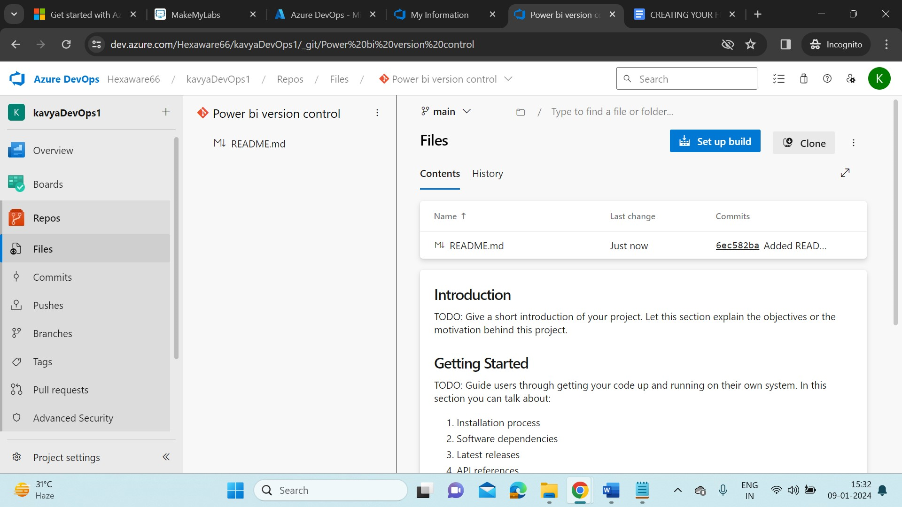

* Click on Clone to work with DevOps in local system.

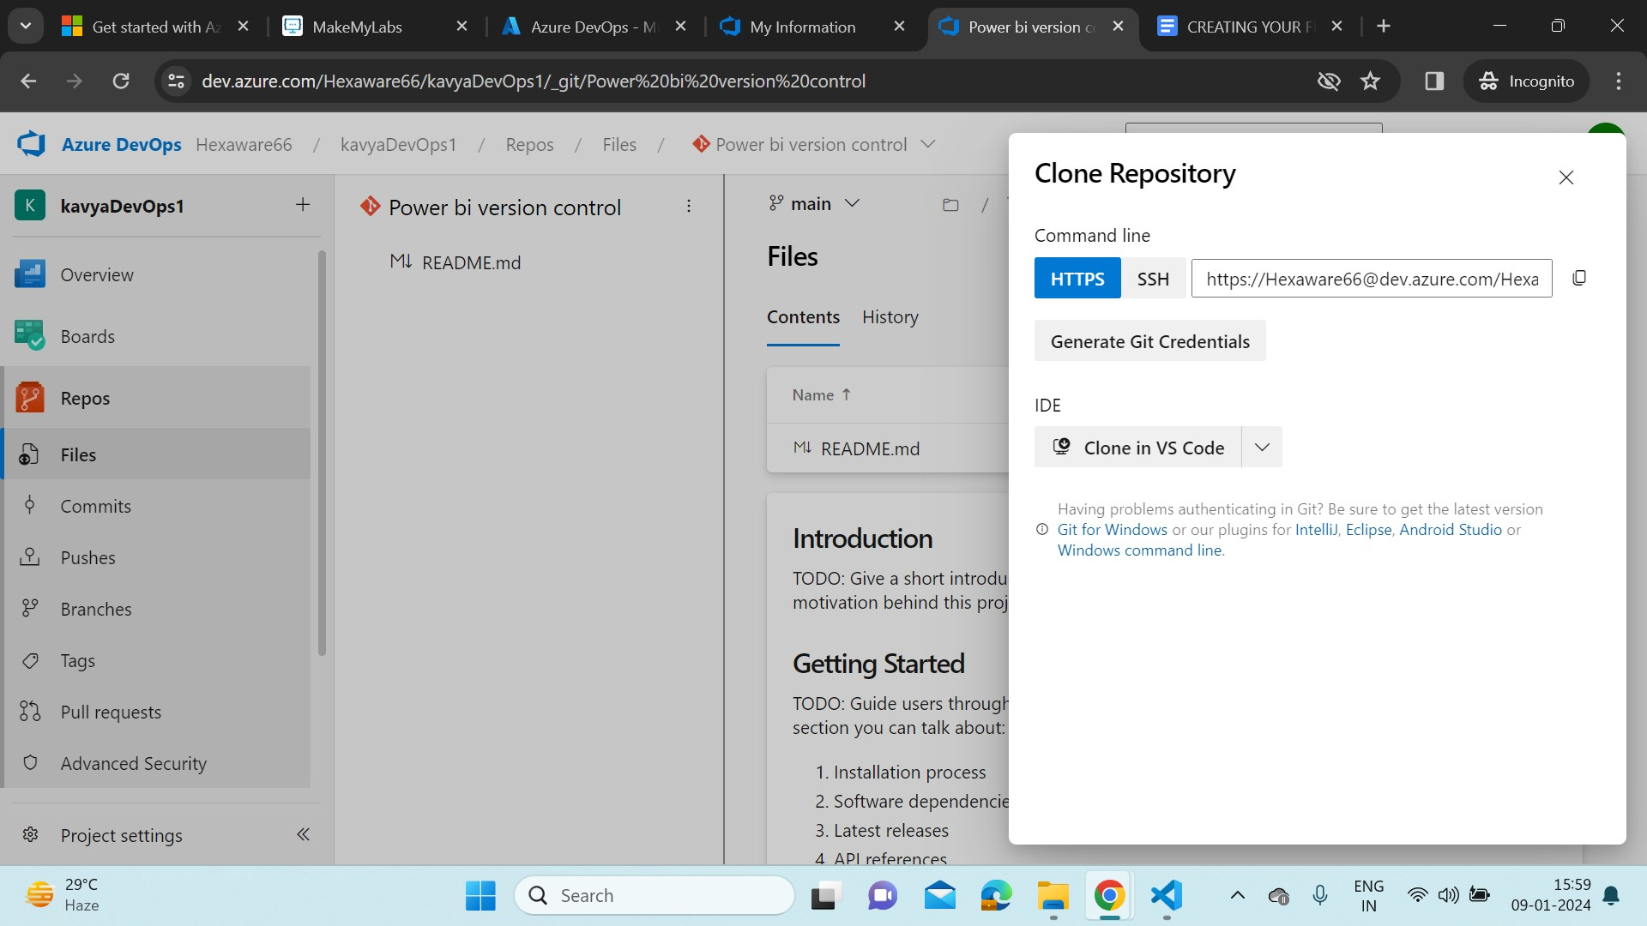

* Copy HTTPS link and select IDE as Clone in VS code.
* Now, download & install some tools needed to work with a local copy(‘clone’) of our Repo:
* Download Git- <https://www.git-scm.com/downloads> and install it.
* Download Visual Studio code. Add Git Extension Pack, start git-bash extensions in Visual studio code.
* Now in Azure DevOps portal, click on Clone in VS code it will redirect us to VS code application. It will ask us to select a git folder as Repository Destination.

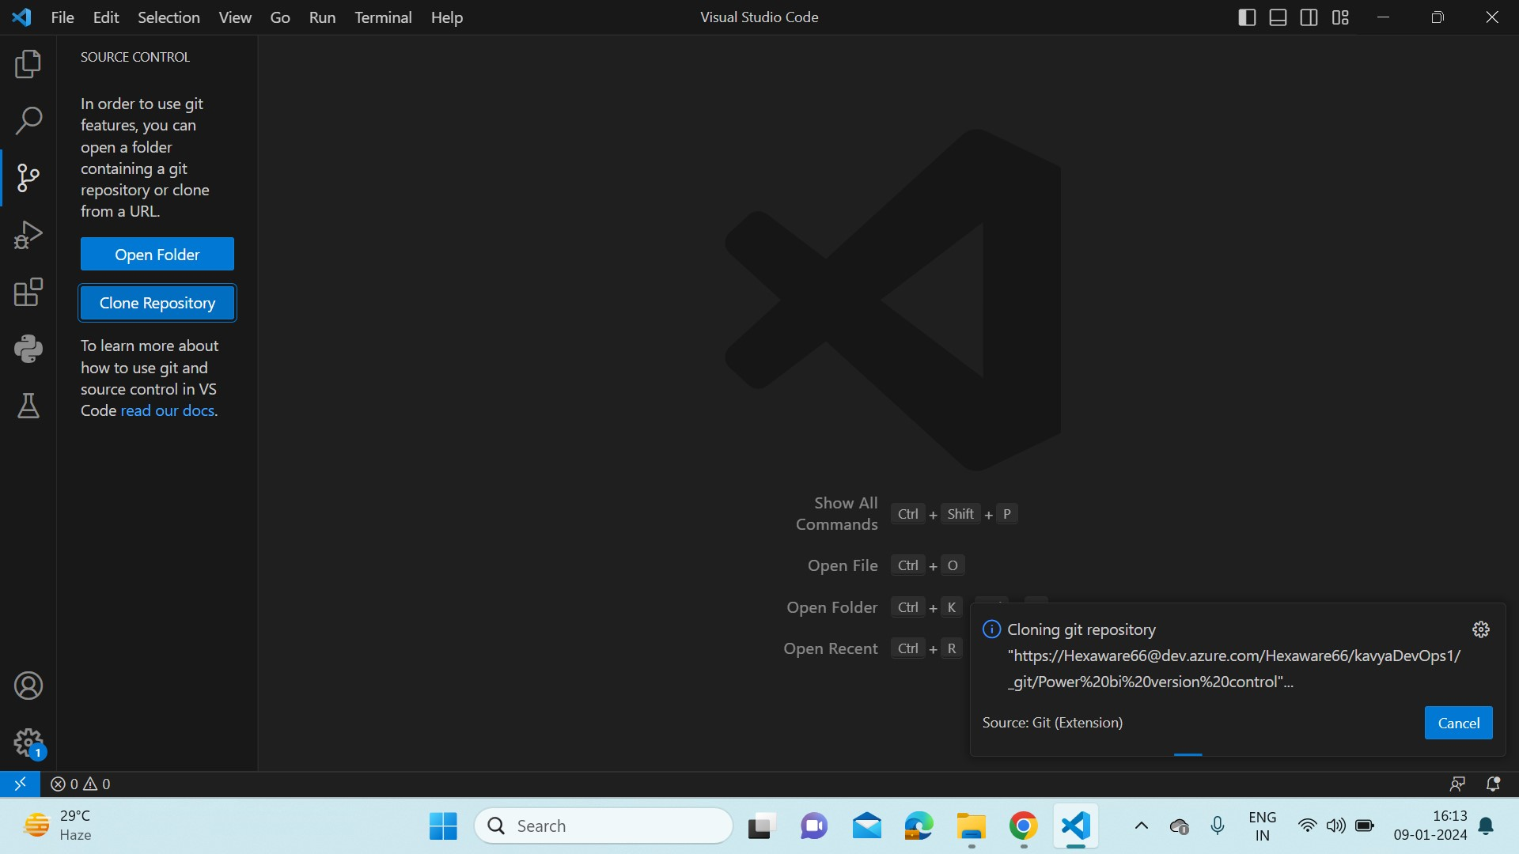

* Click on Clone Repository, it will show us to authenticate with GitHub in browser. Now after authentication, paste the HTTPS link in the search bar. It will ask us to sign in to our Microsoft credentials.

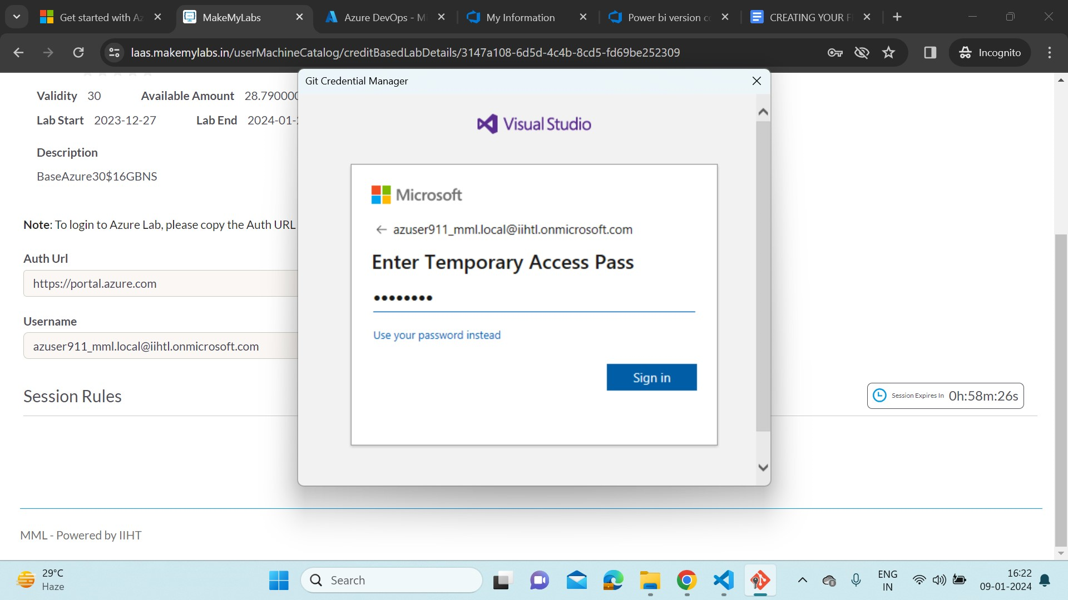

* The cloning operation is done. We can look our DevOps files in our local vs code application.

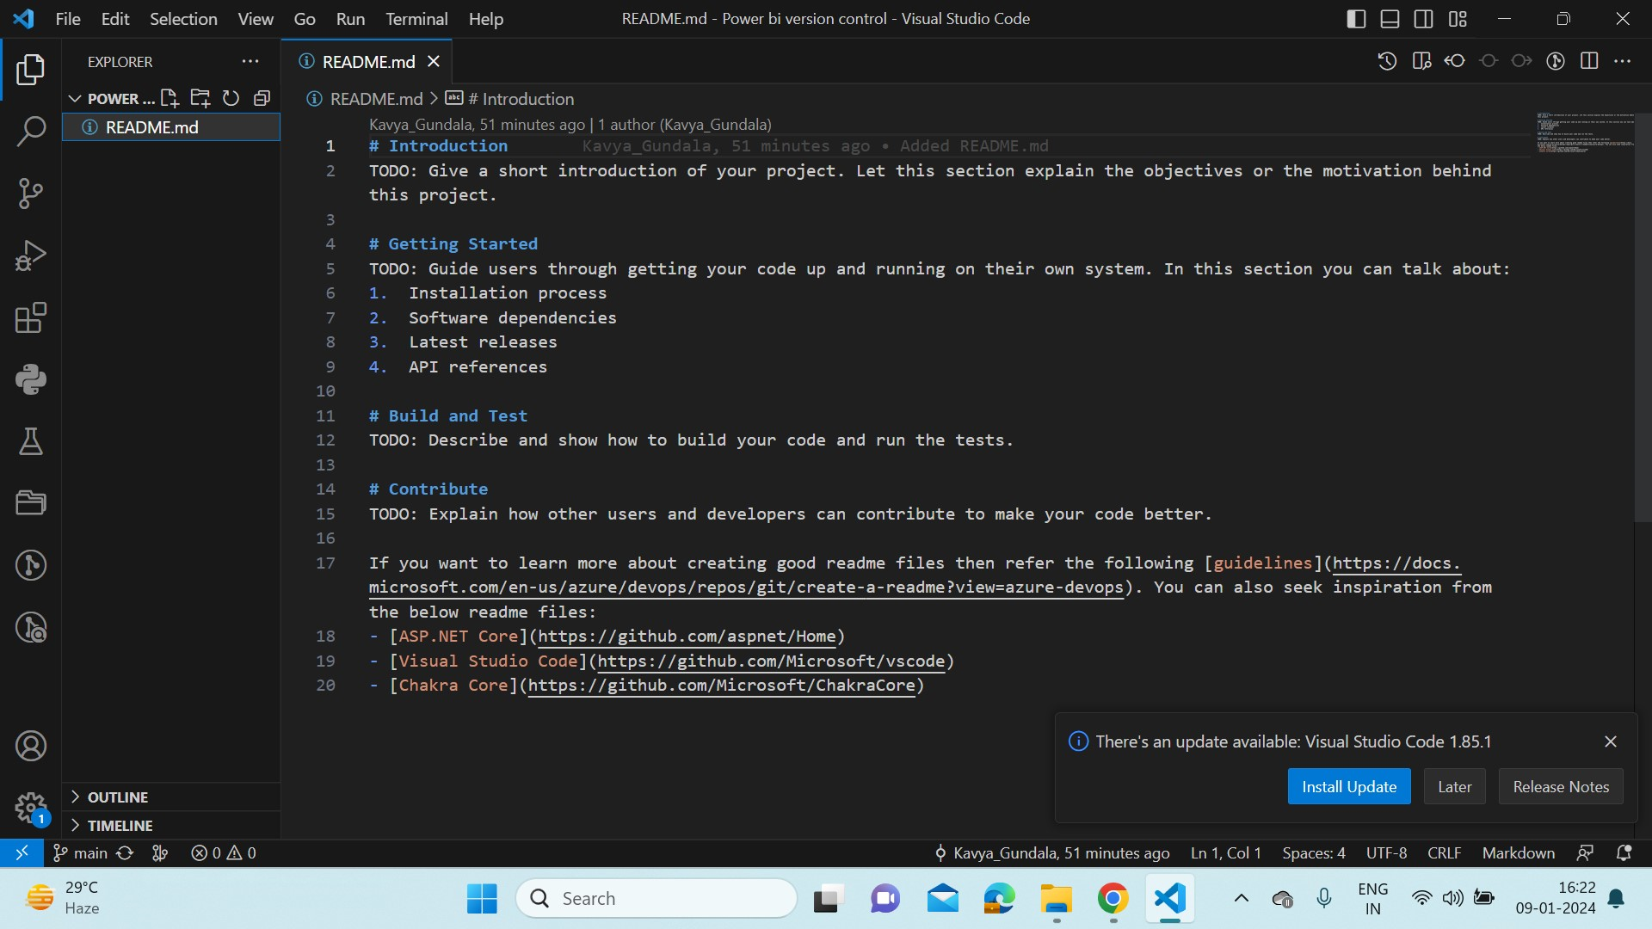

* Now we will access our DevOps Repository by adding some files into it. Click on Set up build and click on upload file(s).

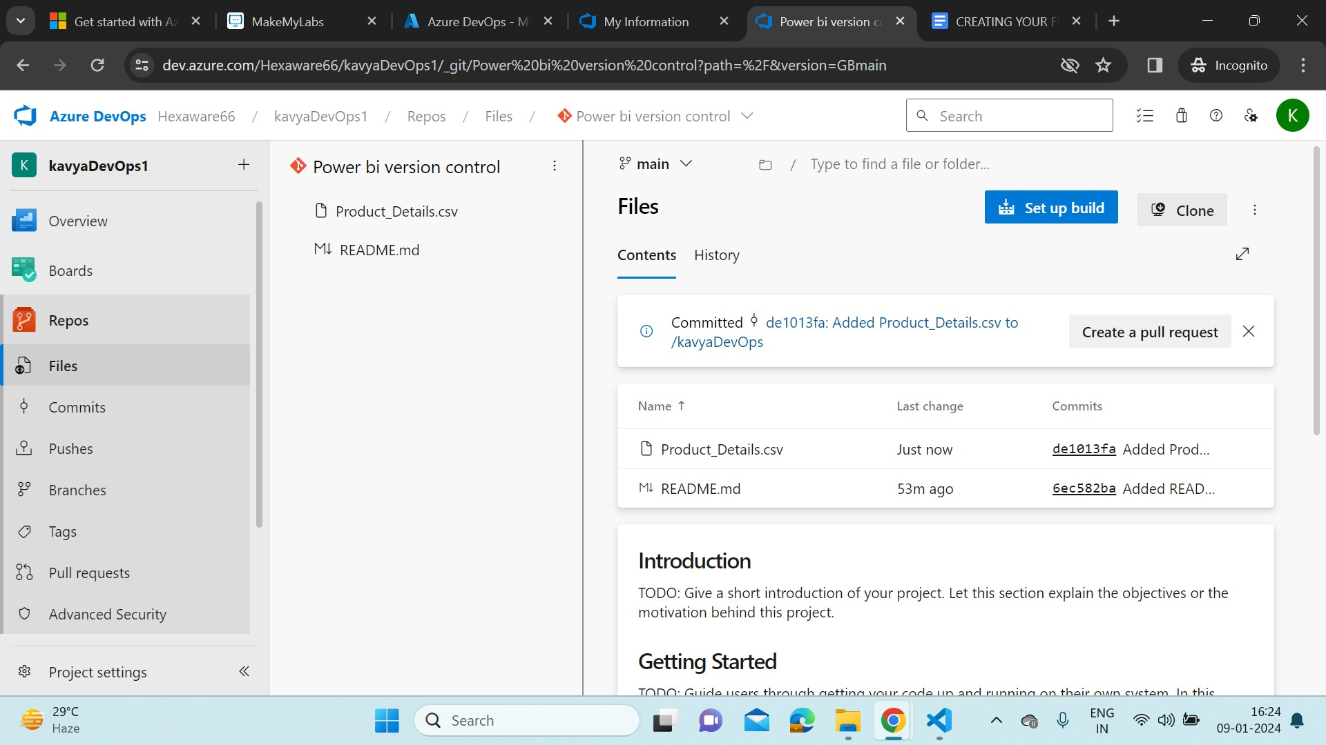

* After the file is successfully added in the Repo. Open VS code and open a new terminal. Start initializing git in VS code with below command.
* git init – to initialize a folder as git folder.



* Command “ls” obviously we can only see README.md file because we didn’t pull the changes occurred.
* ls – lists the current directory contents

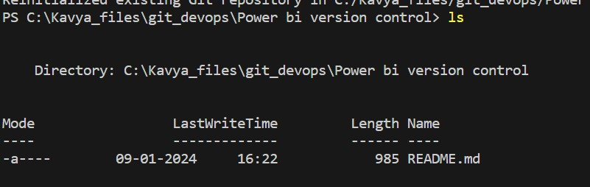

* So command – git pull origin main.
* git pull - to fetch changes in remote repo.

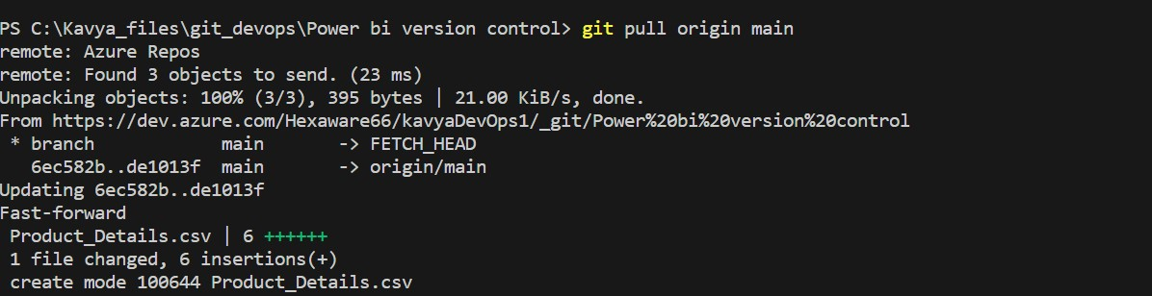

* Now check with ls command.

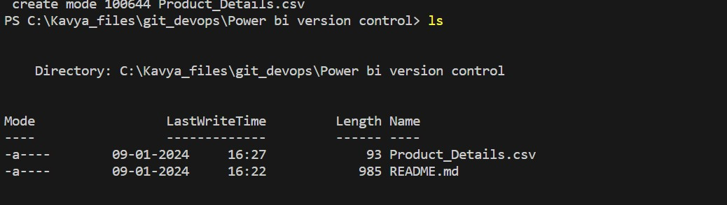

* Now, try editing an existing file and upload into remote repository. To do that follow the steps below, Edit the README.md file and save it.

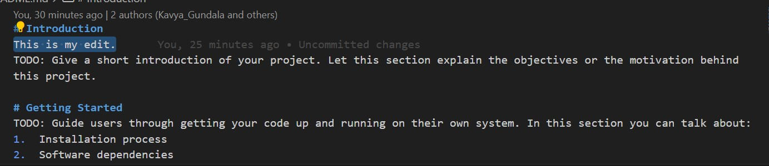

* git status – provides the current status of the git folder.

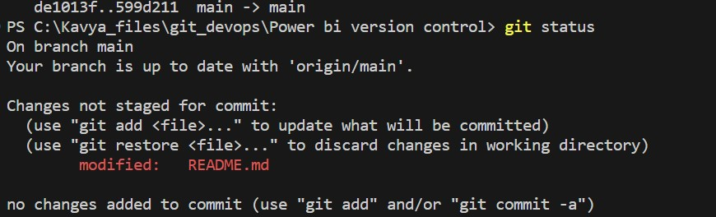

* Add the changed file to the git folder.
* git add – To add files from working directory to staging area.

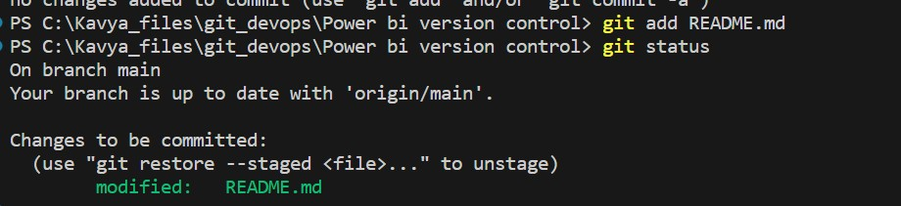

* Now add the modified folder from staging area to the local Repository. To do that,
* git commit – to add files from staging area to local repo. We can additionally add message like “firstedit”.

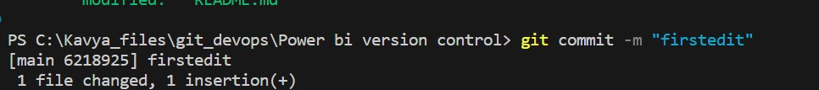

* Now add the modified folder from local repo to remote repo.
* git push - to add files from local repo to remote repo.

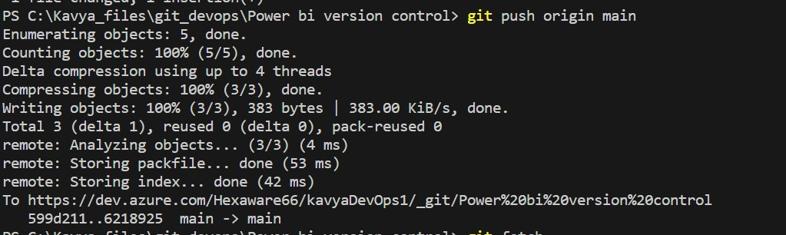

* We can see the changes in Remote DevOps Repo.

h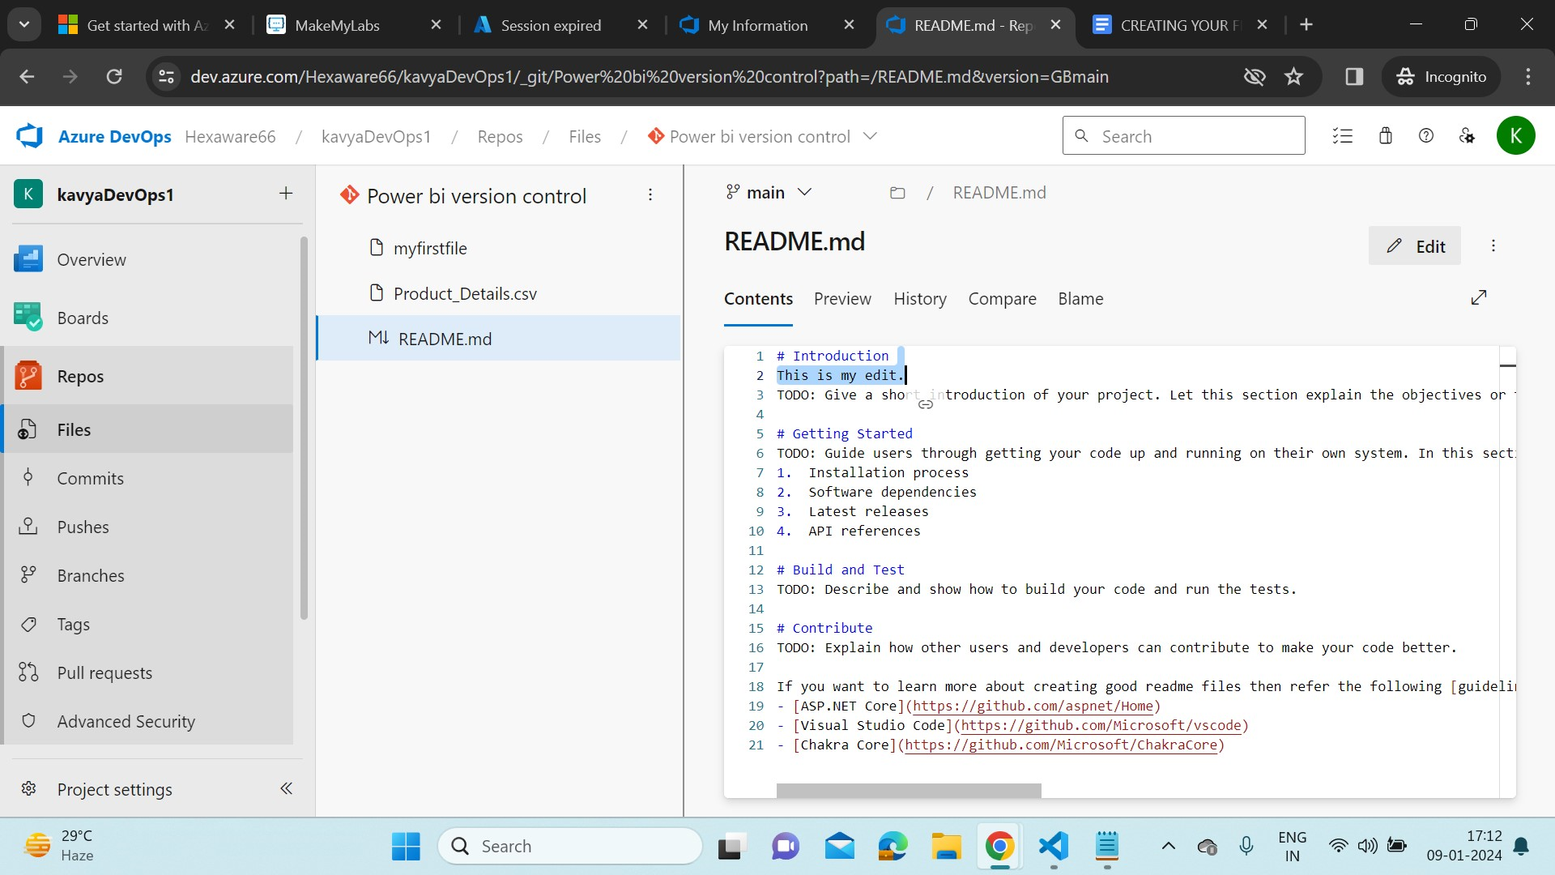

* We can see the commits in the History tab.
* Now we create a new file in our working directory, and upload to remote repo. To do that,
* Create a file named “myfirstfile” in the current directory. And save it.

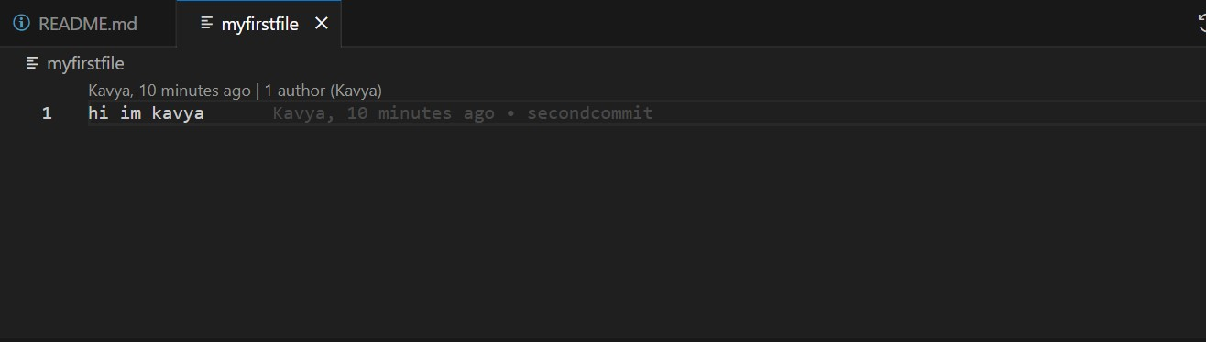

* Now add the file from working directory to staging area. And commit the changes from staging area to local repo.

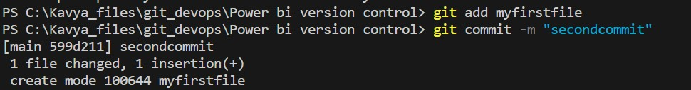

* We can see the created file in our git folder.

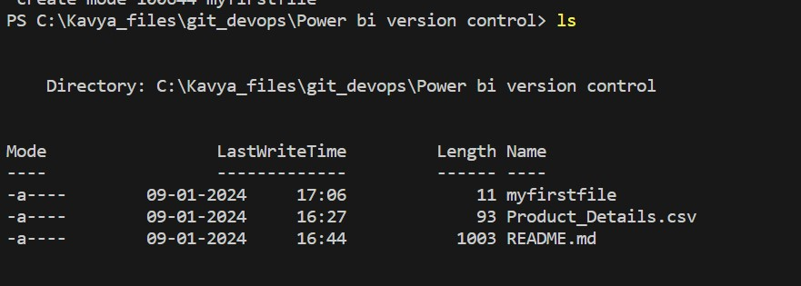

* Now push the file from local repo to remote repo.

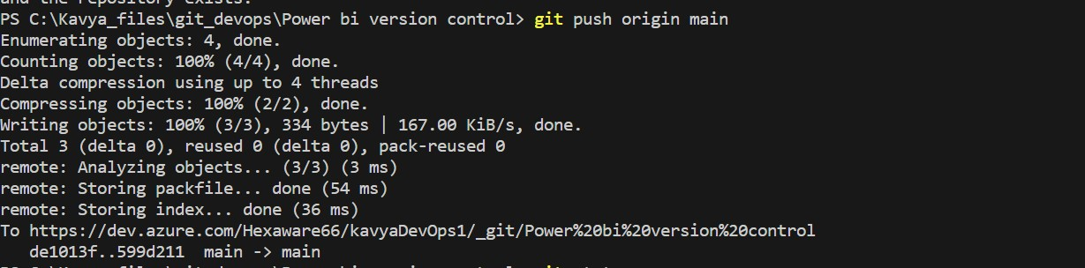

* Check the status of our working directory if there are any changes left to push/pull.

